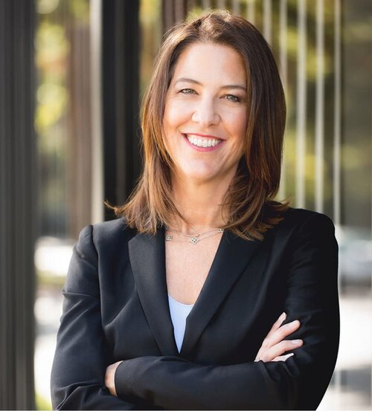

Jennifer Crum – A Committed Mentor

In Addition to being a Certified Family Law Specialist and a Partner at Hanson Crawford Crum,

Jennifer has served as a Mentor for the AAML South Bay Mentorship Group for over nine years and is still serving as an impromptu Mentor for her last group of graduated Mentees. (Another reason we are looking to form an Advanced Mentorship Group.)

Jennifer Crum draws upon nearly 25 years of experience untangling complex assets acquired in the unique Silicon Valley tech economy. Jennifer combines her mastery of high-asset marital dissolutions with compassion for the emotional and personal transition her clients are experiencing.

Expert Guidance in Complex Divorces
Jennifer is highly experienced in divorces involving venture capital, hedge funds, private equity, privately held companies, professional practices and real estate interests.
Her clients include prominent entrepreneurs and leaders in the San Francisco Bay Area who value privacy and discretion in their personal matters.
Known for customized, big-picture and forward-facing strategies, Jennifer strengthens clients’ positions across a wide range of divorce resolution forums. She has gone the distance to achieve her clients’ goals—before private judges and in public courtrooms—and has negotiated settlements that allow her clients to move on with their lives positively.

Jennifer the Person. Jennifer is an outdoor enthusiast and proud mother of daughters, Jennifer is an alumna of UC Berkeley and earned her J.D. from University of San Francisco. Super Lawyers magazine has recognized Jennifer since 2009 as a Northern California “Super Lawyer.” Jennifer is a Fellow of the American Academy of Matrimonial Lawyers, where she serves as a mentor leader.

Recognition
Northern California “Super Lawyer” by Super Lawyers Magazine (2009–present)
Best Lawyers in America- Family Law, San Francisco (Best Lawyers, 2020)

Education
BA, University of California, Berkeley (1988)
JD, University of San Francisco (1996)

Professional Associations & Memberships
American Academy of Matrimonial Lawyers
Association of Certified Family Law Specialist
San Mateo County Bar Association

Boards
Association of Certified Specialists (2006-2009)
American Academy of Matrimonial Lawyers (2013)
Girls United (2004-2007)
JDRF – Tee to Table (2019-2022)

Articles and Speaking Engagements
Co-Authored article entitled “How Can My Divorcing Clients Plan Their Estates with the ATROs in the Way,” ACFLS Newsletter and the California Trust & Estate Quarterly.

